Apl – Lab4

Screenshot -1 (powers.f90)

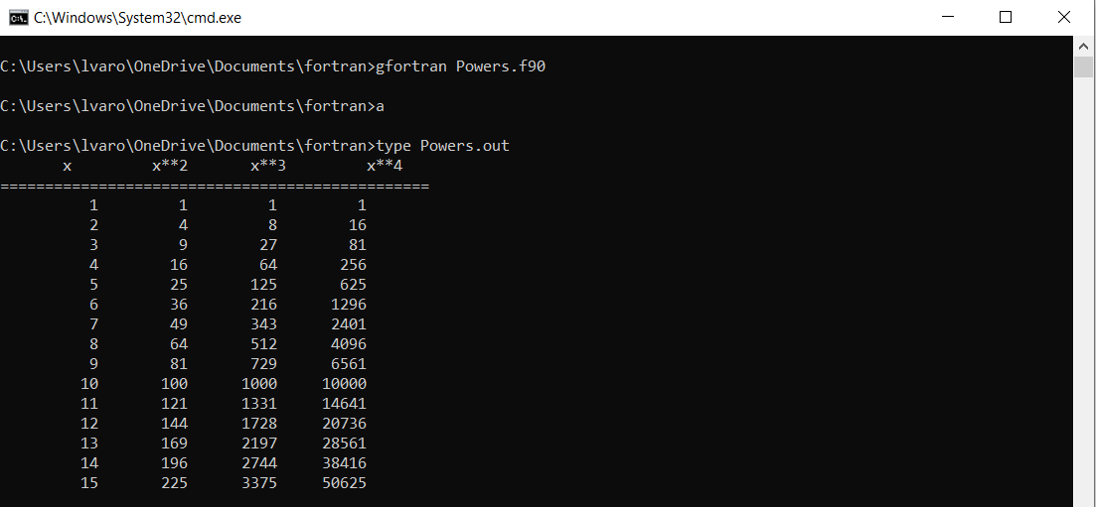

Screenshot – 2 (conpay.f90)

